Syeda Reeha Quasar

14114802719

4C7

Aim

Algebra of Matrices

a) To find transpose of a matrix.

b) To find addition of two matrices.

c) To find multiplication of two matrices.

Experiment - 1

APPLIED MATHEMATICS LAB

# **EXPERIMENT – 1**

## **Aim:**

Algebra of Matrices

a) To find transpose of a matrix.

b) To find addition of two matrices.

c) To find multiplication of two matrices

# **To Find transpose of a Matrix**

**Source Code:**

m = input('Enter no. of rows of matrix')

n = input('Enter no. of columns of matrix')

A = zeros(m, n);

B = zeros(m, n);

disp('Enter elements of matrix row wise ')

for i = 1:m

for j = 1:n

A(i, j) = input('');

end

end

for i = 1:n

for j = 1:m

B(i, j) = A(j, i);

end

end

disp('The Matrix is ', A)

disp('The Transposed matrix is ', B)

# **Output:**

# 

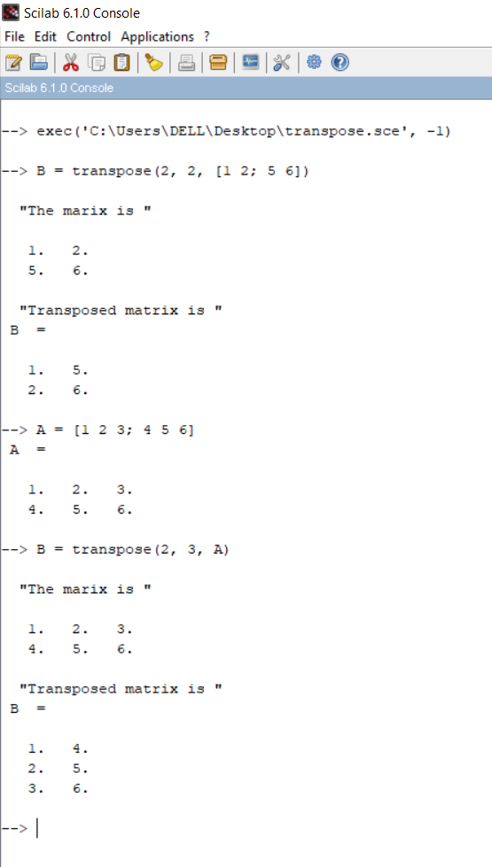

# **To Find Addition of two Matrices**

**Source Code:**

m = input('Enter no. of rows')

n = input('Enter no. of columns')

A = zeros(m, n)

B = zeros(m, n)

C = zeros(m, n)

disp('Enter elements of first matrix row wise ')

for i = 1:m

for j = 1:n

A(i, j) = input('')

end

end

disp('Enter elements of second matrix row wise ')

for i = 1:m

for j = 1:n

B(i, j) = input('')

end

end

for i = 1:m

for j = 1:n

C(i, j) = A(i, j) + B(i, j)

end

end

disp('First Matrix is ', A);

disp('Second Matrix is ', B);

disp('Sum of the matrices is ', C);

# **Output:**

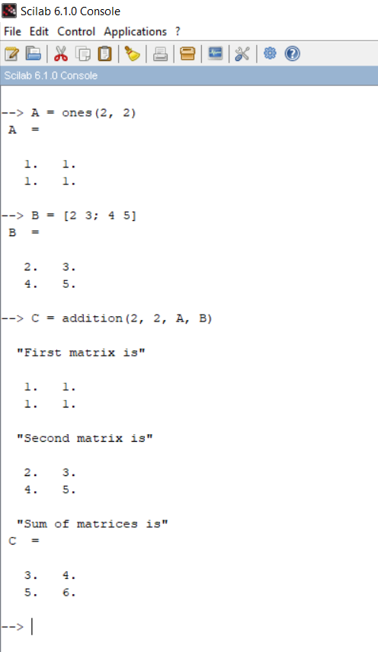

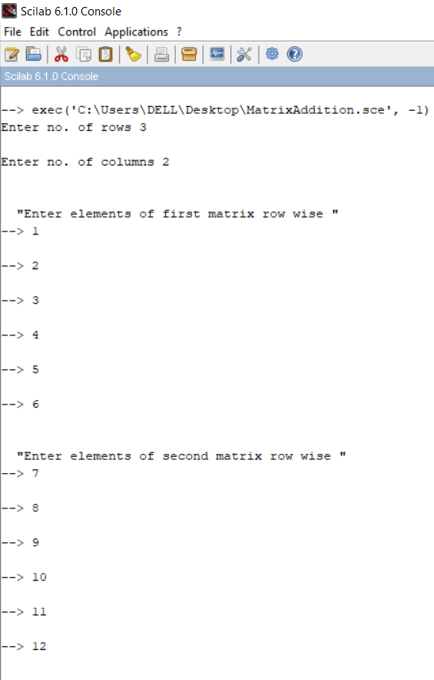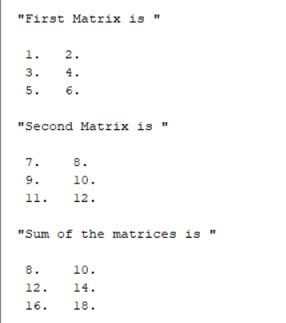

**Source Code:**

function [**C**]=addition(**m**, **n**, **A**, **B**)

**C** = zeros(**m**, **n**);

**C** = **A** + **B**;

disp('First matrix is', **A**)

disp('Second matrix is', **B**)

disp('Sum of matrices is')

endfunction

# **Output:**

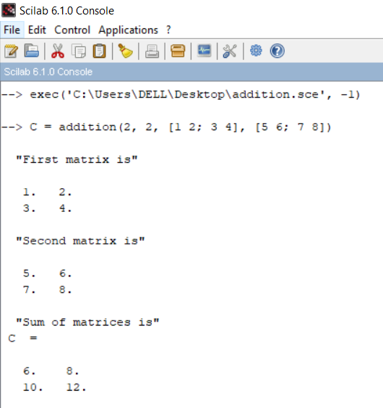

# **To Find multiplication of two Matrices**

**Source Code:**

m = input('Enter no. of rows columns of first matrix')

n = input('Enter no. of columns of first matrix')

p = input('Enter no. of rows of second matrix')

q = input('Enter no. of columns of second matrix')

if n == p then

disp('Matrices are confortable for multiplication')

else

disp('Matrices are not confortable for multiplication')

abort

end

A = zeros(m, n)

B = zeros(p, q)

C = zeros(m, q)

disp('Enter elements of first matrix row wise ')

for i = 1:m

for j = 1:n

A(i, j) = input('')

end

end

disp('Enter elements of second matrix row wise ')

for i = 1:p

for j = 1:q

B(i, j) = input('')

end

end

for i = 1:m

for j = 1:q

for k = 1:n

C(i, j) = C(i, j) + (A(i, j) * B(k , j))

end

end

end

disp('First Matrix is ', A);

disp('Second Matrix is ', B);

disp('Product of the matrices is ', C);

# **Output:**

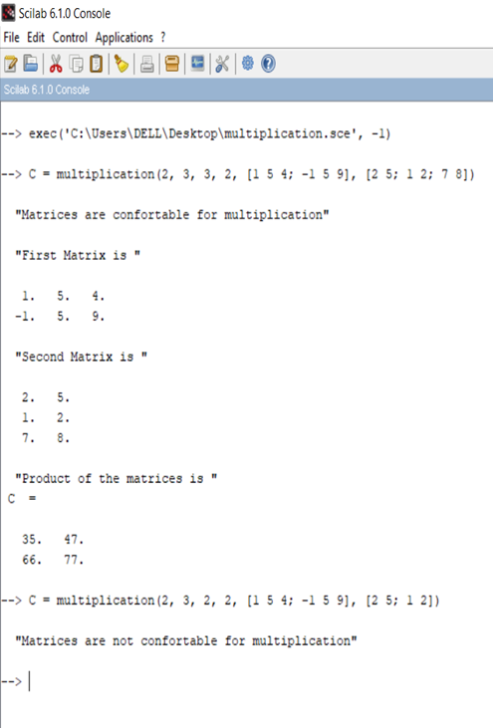

# 

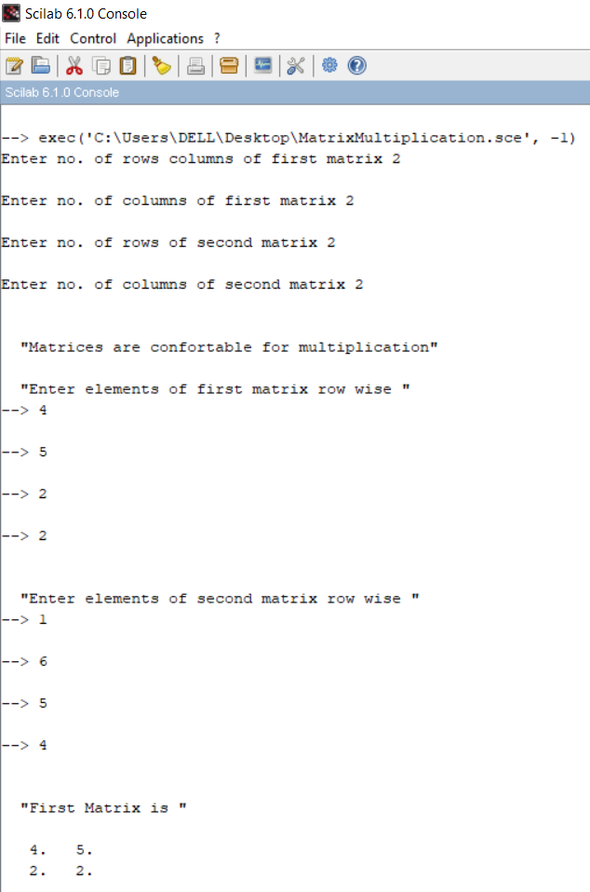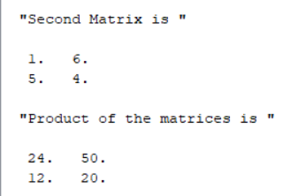

# **To Find multiplication of two Matrices**

**Source Code:**

function [**C**]=multiplication(**m**, **n**, **p**, **q**, **A**, **B**)

**C** = zeros(**m**, **n**)

if **n** == **p** then

disp('Matrices are confortable for multiplication')

else

disp('Matrices are not confortable for multiplication')

abort

end

**C** = **A** * **B**

disp('First Matrix is ', **A**);

disp('Second Matrix is ', **B**);

disp('Product of the matrices is ')

endfunction

# **Output:**

